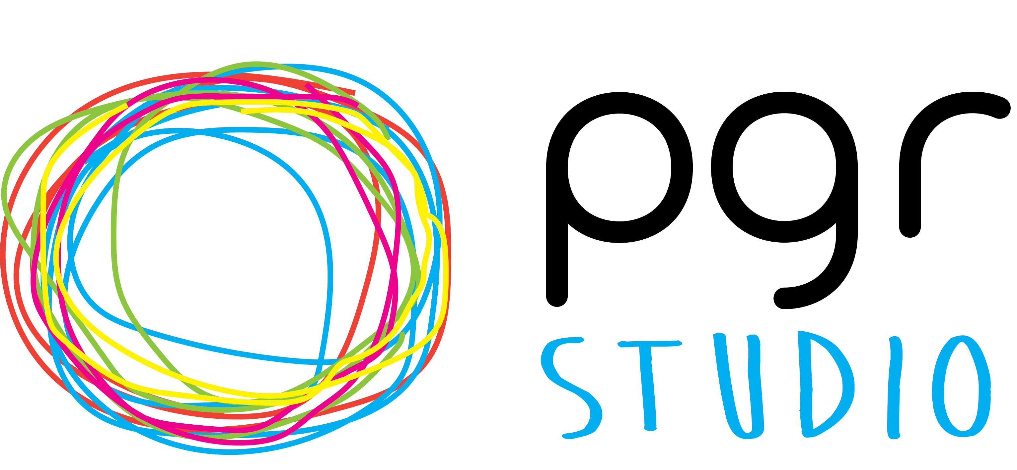

PGR STUDIO RESEARCH(ER) RESIDENCIES

Our new Research(er) Residencies enable Arts, Design & Media (ADM) doctoral researchers to work closely with us to lead on a focused project. This might be a particular activity, event or initiative but should all have the purpose of enhancing the the ADM doctoral community, environment, and experience.
The residencies are similar in their ethos to a micro-placement in that you will be able to obtain professional experience but also have a wider focus on knowledge exchange: you gain knowledge and experience from working with us in both research and doctoral teaching and learning contexts ... and … the doctoral community is enhanced by your unique skills, insights, and expertise!
The residencies are flexible, and we will work closely with you to make sure that they fit in with your PhD and other commitments. We are keen that they complement rather than hinder your research(er) experience and that you take ownership about the design, duration and focus of the residencies. You will also receive mentoring from a member of The PGR Studio team as well as demonstrable academic experience to go on your CV.
Some examples of proposed projects might include but are not limited to:
>> Inside//Out festival | E.g., organising, designing and /or marketing the annual festival
>> Mentoring scheme | E.g., managing this year’s mentoring scheme, callout and/or launch event
>> Social media and web presence | E.g., overhauling, redesigning and/or managing online content
>> Electronic resources | E.g., converting the viva 60-second interviews into a e-book
>> You tell us!
There is a rolling deadline for applications, although we will post specific callouts at various times in the year for particular events such as the Inside//Out festival and annual conference.

If you would like access to funding to run a one-off specific event then you can do so through the Researcher Development Awards, which will be opening in January 2022. More information and examples of previous funding awards can be found on The PGR Studio website here.

APPLICATION FORM

PERSONAL DETAILS
Name:
School:
Stage in PhD:
Mode of study: | Full-time | Part-time

ABOUT THE RESIDENCY
Title of proposed residency:
Proposed duration of residency:
Proposed start date:
A summary of your proposed project:

ABOUT YOU
- Why do you want to undertake a Research(er) Residency?
- What sort of skills and experience would you bring to the residency?
- Please provide any additional information you feel would be useful in support if your application.

Signature: | Date:

Please email your completed application to admpgr-studio@bcu.ac.uk

