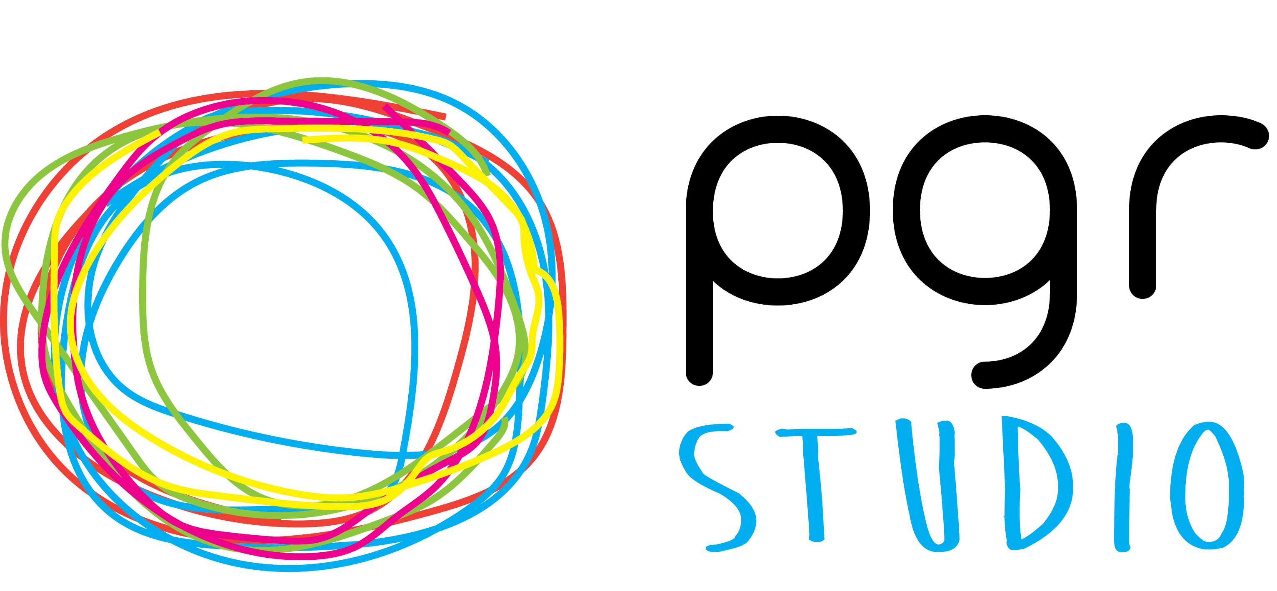

PGR STUDIO RESEARCHER DEVELOPMENT AWARDS

The PGR Studio’s Researcher Development Awards enable Arts, Design & Media (ADM) doctoral researchers to apply for funding to organise and facilitate development initiatives. Funded activities must clearly benefit doctoral researchers across ADM (or within smaller research areas) and enhance the ADM doctoral environment and community. Initiatives could take the form of workshops, events, training, or social activities and should take place before 31/07/2024.
Applications are particularly welcome that:
- are developed collaboratively between doctoral researchers in different ADM schools;
- bring together doctoral researchers across disciplines within ADM;
- enhance the profile and visibility of the ADM doctoral community;
- are innovative, engaging and interactive.
This form is to register your initial interest for a Researcher Development Award. If you are successful at this stage, The PGR Studio will work with you to develop a full proposal.
STAGE 1

Complete Expression of Interest form and send to The PGR Studio

Assessed by peer review panel (every 6 weeks)
Feedback from panel to all applications

Unsuccessful applications
Invited to reapply

Invited to Stage 2
Successful applications
invited to Stage 2

STAGE 2

Invitation to develop full proposal

Development of aims, project plan, budget and outcomes

Award agreement signed when approved and funds released

Blog post summary and impact report after event

More information and examples of previous funding awards can be found on The PGR Studio website here.

Researcher Development Awards
EXPRESSION OF INTEREST

PERSONAL DETAILS
Name(s):
School(s):
Stage in PhD:

ABOUT THE PROJECT
Title of proposed initiative:
Duration of project:
Start Date / End date:
Summary of proposed initiative, why it is important and how it will benefit ADM doctoral researchers (Max 200 words):

Please email your completed application to admpgr-studio@bcu.ac.uk. There is a rolling deadline for Expressions of Interest however the last submission deadline for the current academic year is 1st March 2024.
Please note that funds are allocated to successful projects on a first-come first-served basis, and it is recommended that you submit an Expression of Interest as soon as possible.

